

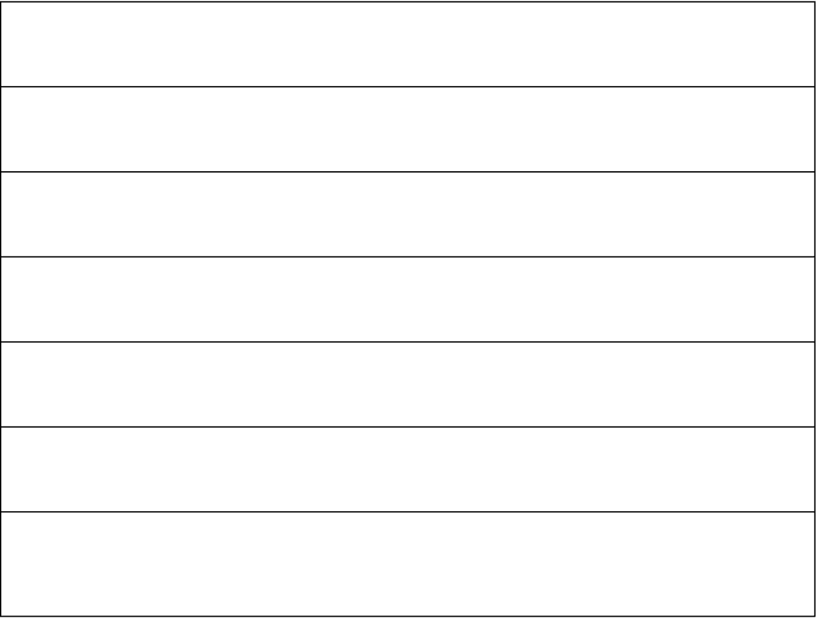
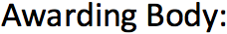
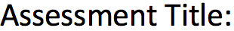
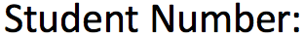
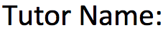
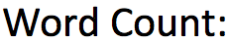
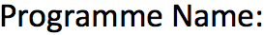

Task 1

1. Introduction to the UML Class Diagram
For the MyFitness system design, I have developed a comprehensive UML Class Diagram to visually represent the static structure of the application. UML is an object-oriented visual modeling language used to specify and construct the components of a software system. The Class Diagram was chosen as it perfectly depicts the system's classes, their internal attributes, behaviors (methods), and the structural relationships between them.

Each class in the diagram is structured into three horizontal sections: the Class Name at the top, the Instance variables (Attributes) in the middle, and the Behaviors (methods) at the bottom.

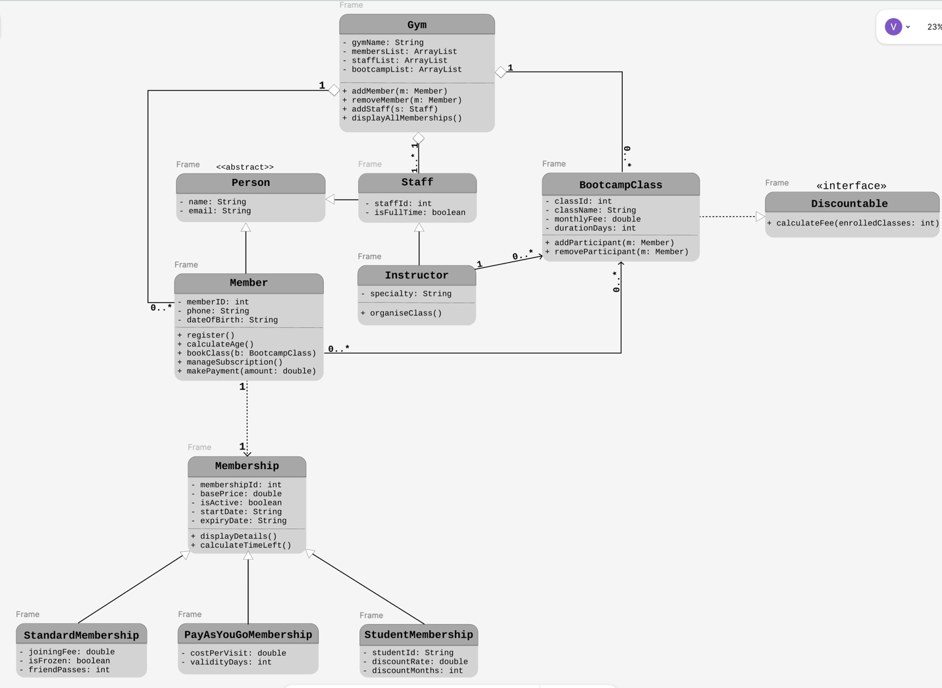

2. Application of Core OOP Principles
The diagram strictly adheres to the four main pillars of Object-Oriented Programming (OOP):
- Encapsulation: All class attributes (such as - name, - memberID, - monthlyFee) are defined as private (denoted by the -sign). This ensures that internal data is hidden and protected and can only be accessed or modified through controlled public methods (denoted by the + sign).
- Abstraction: Abstraction denotes the essential characteristics of an object that distinguish it from all other kinds of objects. This is demonstrated by the <<abstract>> Person class. The system does not need to instantiate a generic "Person", but rather specific members or staff. Additionally, the <<interface>> Discountable is used to abstract the behavior of calculating fees with discounts.
- Inheritance: To follow the DRY (Don't Repeat Yourself) principle and avoid code duplication, I utilized inheritance hierarchies. The Member and Staff classes inherit common attributes (name, email) from the Person superclass. Similarly, Instructor inherits from Staff, and specific memberships (StandardMembership, PayAsYouGoMembership, StudentMembership) inherit from the base Membership class. This is represented by solid lines with hollow triangles pointing to the parent classes.

3. Class Relationships and Cardinality Justification
To accurately reflect the MyFitness business logic, specific relationships and Cardinalities (Multiplicities) were established:
- Gym to Member (1 to 0..*) & Gym to Staff (1 to 1..*): These relationships are modeled using Aggregation (solid lines with hollow diamonds at the Gym end). A single Gym (1) contains multiple ArrayLists: one for members (who can range from zero to many, 0..*) and one for staff. The cardinality for staff is 1..* because the case study explicitly states the gym employs a specific number of full-time and part-time staff to operate.
- Member to Membership (1 to 1): Modeled as an Association (dashed line). Once registered, every single member (1) is required to choose exactly one active membership plan (1).
- Member to BootcampClass (0..* to 0..*): This represents a Many-to-Many association. A member can book multiple bootcamp classes, and a single bootcamp class can have multiple members enrolled.
- Instructor to BootcampClass (1 to 0..*): A single instructor (1) can organize and manage zero or multiple (0..*) bootcamp programs.
- BootcampClass to Discountable Interface: Modeled using a Realization relationship (dashed line with a hollow triangle). BootcampClass implements the interface to fulfill the case study requirement of offering a 7% discount.

4. Key Class Behaviors and Design Choices
While standard getters and setters will be implemented in the Java code for encapsulation, the UML diagram highlights the core business methods:
- + calculateAge(): int (Member Class): Instead of storing age as a static integer variable (which becomes outdated), the system stores - dateOfBirth. The calculateAge() method dynamically calculates the member's current age. This is critical for verifying the case study requirement that members must be "aged 18 and above" and for identifying senior citizens for discounts.
- + calculateFee(enrolledClasses: int) (Discountable Interface): This method enforces a standardized way to calculate the final price, ensuring the 7% discount logic for bootcamps is applied cleanly and consistently across the system.

